Reflection Guide

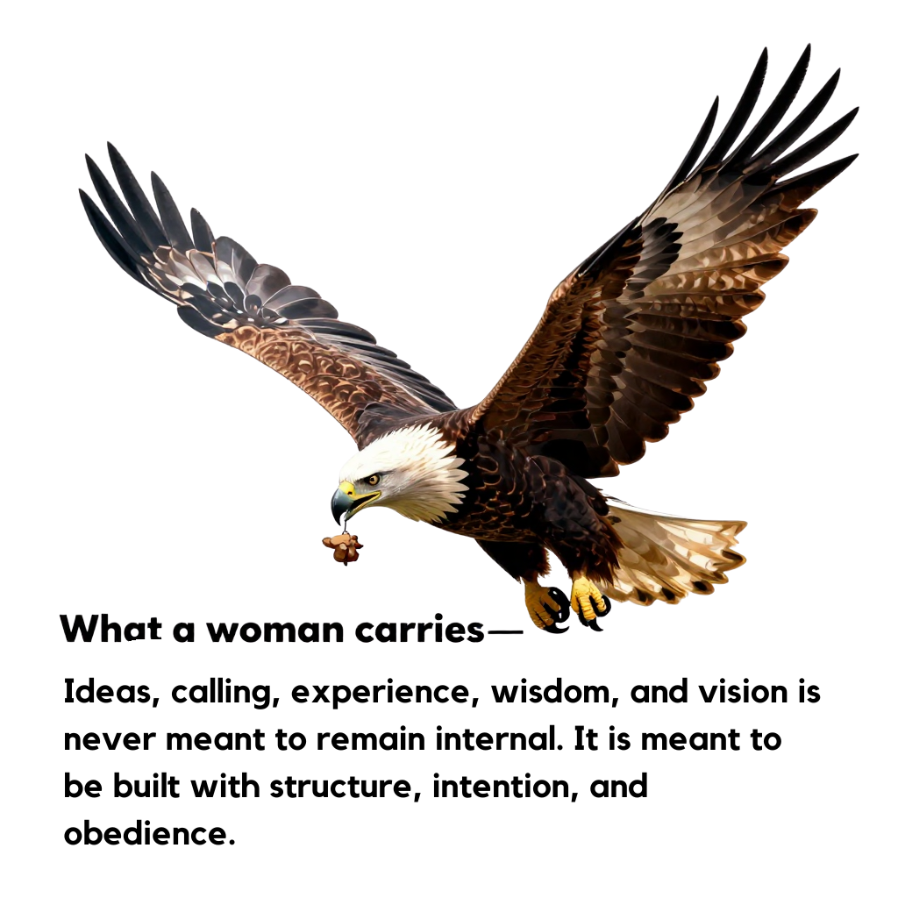

WHAT YOU CARRY IS MEANT TO BE BUILT

For Businesswomen & Author
“For we are God’s workmanship, created in Christ Jesus to do good works.” (Ephesians 2:10)
You are both the carrier and the builder.

THE S3 BUILD FRAMEWORK

S1 — SHOW UP: LAY THE FOUNDATION
Build Focus: Positioning, consistency, ownership
Businesswomen
- Showing up means treating your business as a structure, not a side idea
- Establishing systems, pricing, and presence
- Making decisions aligned with growth, not fear
Authors
- Writing with discipline, not mood
- Claiming authorship before publication
- Respecting your message enough to give it time and space
📖 “The wise woman builds her house.” (Proverbs 14:1)
Reflection
- What have I been carrying that I have not yet committed to building?
- Where do I need to show up with greater consistency?
- What foundation must be strengthened before growth?

S2 — SPEAK OUT: RAISE THE FRAME
Build Focus: Voice, clarity, authority
Businesswomen
- Articulating your value clearly
- Speaking confidently in leadership and negotiations
- Communicating vision to clients and collaborators
Authors
- Writing boldly without shrinking your message
- Sharing excerpts, insights, and themes publicly
- Trusting that your words have assignment
📖 “Death and life are in the power of the tongue.” (Proverbs 18:21)
Reflection
- Where have I minimized my voice during the building process?
- What truth, strategy, or story must be spoken now?
- How does speaking bring structure to what I carry?

S3 — SHARE IT: COMPLETE AND RELEASE
Build Focus: Stewardship, multiplication, legacy
Businesswomen
- Packaging what you know into scalable offers
- Creating solutions that outlive your presence
- Building impact alongside income
Authors
- Publishing instead of perfecting endlessly
- Allowing your book to serve beyond you
- Viewing your work as legacy, not just product
📖 “Whatever your hand finds to do, do it with all your might.” (Ecclesiastes 9:10)
Reflection
- What am I afraid to release once it is built?
- Who is waiting for what I’ve been carrying?
- How does sharing complete the assignment?

DECLARATION: BUILDER’S CONFESSION
I acknowledge that what I carry is intentional and God-given.
I will not bury it, delay it, or downplay it.
I will show up, speak out, and share what I have been entrusted with.
I build with wisdom, faith, and obedience.
What I carry is meant to be built—and released for impact.
📖 “He who began a good work in you will bring it to completion.” (Philippians 1:6)

©2025DrAnnetteWest

